Character Selection Menu

Since I am working alone and the documentation is still work in progress, it might need some more improvements.
If you think that something is missing in the documentation, or something is unclear, please contact me under: gamedevibk@gmail.com
I will be glad for any feedback and to improve the documentation to your suggestions!

Table of Content:
- Overview
- Add DoTween for animation.
- Create your own characters
- Keep track of all Characters
- Make CharacterClass filtering available with new classes

- Appendix A: Overview of Script dependencies

1.Overview
This character selection menu enables you to switch between all unlocked characters and see all the needed information of the selected character, like:
- Current level
- Current experience and needed experience for level up
- Description
- Passive effects
- Special skill of the character
- Character class / Race / Fraktion
- Rank image (characters have Rank 1-4 where R1 is the weakest, and R4 the strongest)

2.Add DoTween for animation
This package uses the DOTween (HOTween v2) asset, which is available for free on the asset store.
This is used for animating the light object of the selected character ( the light will move around all edges of the image)

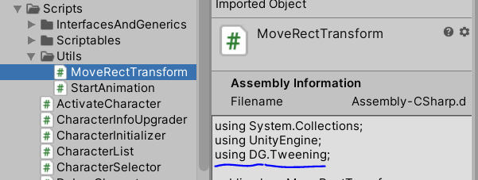

3.Create your own characters
Characters are created from the ScriptableObject “Character”, as well as Skills and CharacterClasses.
To create one of those objects, simply right-click on a project folder → create → characters
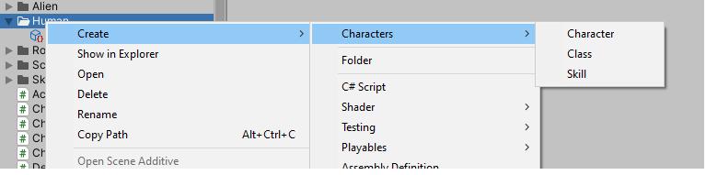

After creating the Character object you can specify the details, like description, Rank, characterClass, etc …
It works the same with CharacterClass and Skill Scriptables.

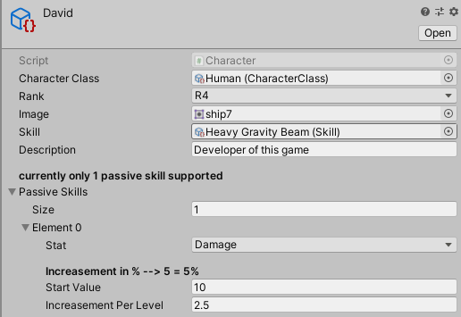

4.Keep track of all characters

After you have successfully created the characters and want to add them to the game, navigate to the CharacterList Prefab and add the new created characters to the CharacterList script.
This script has a static reference and is attached to the scene, so the character initialization is based on this list.
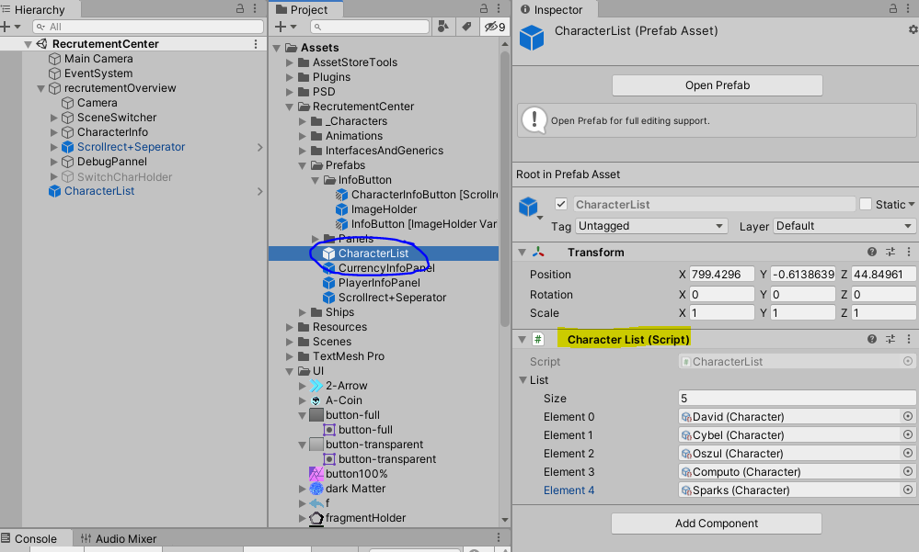

5. Make CharacterClass filtering available with new classes

The default Classes in this package are Human, Alien and Robot. If you rename the classes or want to create more classes, you need to adapt the RaceSeperator to filter for the correct classes.
You should pass the exact same name as you named your CharacterClass to the “FilterByCharacterClass”. E.g. To filter “Human” characters you need to pass “Human” to the method
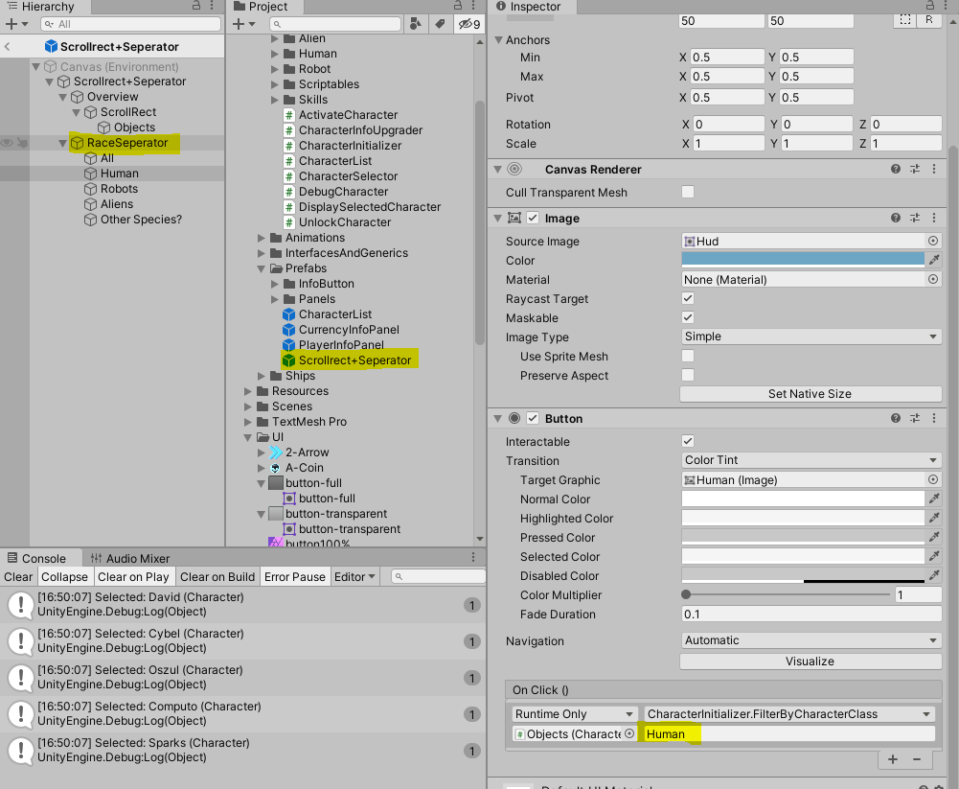

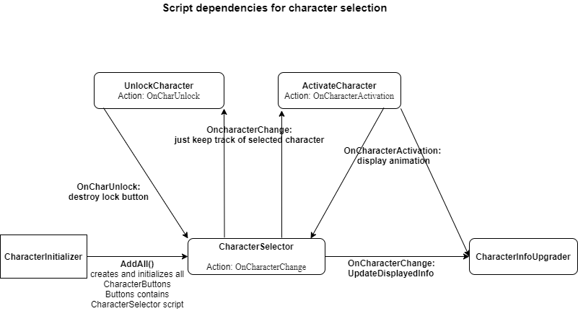
Appendix A

